ADMAS UNIVERSITY

COLLEGE OF COMPUTING AND INFORMATICS

DEPARTMENT OF COMPUTER SCIENCE

**Bishoftu Tourist Guide Integrated with Google Map**

A BISHOFTU TOURIST GUIDE INTEGRATED WITH GOOGLE MAP SUBMITTED TO ADMAS UNIVERSITY IN PARTIAL FULFILLMENT OF THE REQUIREMENTS FOR THE DEGREE OF COMPUTER SCIENCE IN THE COMPUTER SCIENCE IN THE ADMAS UNIVERSITY.

BY

NAME OF THE STUDENTS IDNO

LESANWORK MESFIN

BENAIM EMANUEL

BIRUK SISAY

YEDNEKACHEW HUMITE

LIDET GIRMA

PROJECT ADVISOR: <ADVISOR’S NAME>

Admas University, Bishoftu, Ethiopia

9, 31, 2020

**DECLARATION**

This is to declare that this project work which is done under the supervision of <<Your Advisor Here>> and having the title Bishoftu Tourist Guide Integrated with Google Map is the sole contribution of:

LESANWORK MESFIN

BENAIM EMANUEL

BIRUK SISAY

YEDNEKACHEW HUMITE

LIDET GIRMA

No part of the project work has been reproduced illegally (copy and paste) which can be considered as Plagiarism. All referenced parts have been used to argue the idea and have been cited properly. We will be responsible and liable for any consequence if violation of this declaration is proven.

Date:

**Group Members:**

Full Name Signature

**APPROVAL**

**ACKNOWLEDGMENT**

First of all, we would like to thank almighty god for fiving us blessing, strength and keeping us safe throughout the journey of this project. And we would like to acknowledge our advisor. Next, we would like to acknowledge Admas University and all our instructors. Finally, we would like to express our deepest gratitude to our friend and families of their admirable support throughout the whole journey of this project.

**TABLE OF CONTENT**

List of Figures.…………………………………………………………………………….v

List of Tables….………………….……………………………………………………….vi

List of Abbreviation.……………...……………………………………………………...vii

Abstract…………………………………………………………………………………..vii

CHAPTER 1: INTRODUCTION…...……………………………….…………………....1

1.1 Background of the Organization….…………………………………………………...2

1.2 Statement of the Problem………….…………………………………………………...2

1.3 Objectives of the Project.………….…………………………………………………...3

1.3.1 General Objective……..…….…………………………………………………...3

1.3.1 Specific Objectives………….…………………………………………………...4

1.4 Feasibility Analysis.………….…………………………………………………...........4

**LIST** **OF** **FIGURES**

**LIST** **OF** **TABLES**

**LIST** **OF** **ABRRIVATION**

* CSS – Cascading Style Sheet
* HTML – Hyper Text Markup Language
* DB – Database
* Info – Information
* Js – JavaScript
* UI – User Interface
* UX – User Experience

**ABSTRACT**

Website design and development where the main objectives of this project. To develop a web-based application or software there are several programming languages that are in use. Some of them are only used for the front-end and back-end design of the application. For example- HTML5, CSS3, JAVASCRIPT, etc...

**CHAPTER** **1: INTRODACTION**

Nowadays websites are the most convenient way to present and disseminate information to the maximum number of people in the world. Recent advances in the Web have rapidly changed our life in various ways these advances provide new ways for people to communicate on global scale and assess vast amount of information. And in tourism industry websites are the backbone of the industry travels starts from website. Despite of many benefits there are factors that constrain the Ethiopian tourism competitiveness are limited hospitality facility, land transport factors, difficulty of planning and booking travel and most importantly the limitation human resource and institutional capacity to operate, develop and promote tourism. As we live in the tourist city Bishoftu (Debrezeit) tourism is main income for the town’s community. But despite of being tourist city Bishoftu still uses traditional way of tourism marketing.

**BACKGROUNG OF ORGANZITION**

Bishoftu (Debre Zeit) is one of top tourist destination in Ethiopia

**STATEMETN OF THE PROBLEM**

In digital age, a sense of place is no longer restricted to the physical landscape. Especially for travelers or tourists digital information and guide is very essential before going some ware. Thanks to internet you can get enough information about your destination even before start thinking about traveling. As the world struggling in COVID19 pandemic the first and most doomed industry was tourism industry so that makes travel and tourism websites very essentials for the industry to survive and revive again. But as we saying that in Ethiopia getting information access about your destination is gets harder and that makes the country’s tourism industry not able to compete with neighboring nations in terms of attracting travelers.

So, we come up with the idea that can tackle this problem and limitation in our local city Bishoftu as we know Bishoftu is one of leading tourist destination in Ethiopia. Our proposed system will tackle this problem by giving centralized information for visitors. Of course, there are websites for specific resort or hotel but they only give info about their services so visitors will have limited information about their destination. Some cities in Ethiopia has official sites but even if there are some site easier they’re not well organized or eye-catching. and even though there are some responsive site in Ethiopia they build separately which means one system for mobile phones and another for PC users and that costs development time and resource.

We are proposing the system that is fully responsive web application that can run smoothly in every device and that can attract users. We also countered problem with similarity between website all around the world which is on their frontend design. Almost every website now days either developed by WordPress or used Bootstrap framework that makes website to look very similar and identical. That why we designed our web application to look original and fresh. we also used Zurb foundation framework for our responsive navigation menu which is very flexible, fast, customizable and the most advanced responsive design.

Geospatial data on the web is core component of many of the services businesses offer including maps, geo-tagging and storing of locations, making it essential these days. It also improves end-users experience. However, with that being said it’s still limited have data and have little support. This project aims to address this issue by integrating with Google Maps and by drawing custom markers on the map.

**1.3 Objectives of The Problem**

**1.3.1 General Objective**

The aim of this project is to design and develop a responsive, fast UI friendly web application that allows users to have better experience. Our main mission is to provide visitors easy to access and user-friendly system that can be used before visiting and while visiting their destination.

**Specific Objective**

The primary focus of this application is to support local business and community. Also having easy to use and aesthetically pleasing user interface has been an essential focus for the project.

The following are the specific objectives of this project.

* To reduce responsive web development time and cost.
* Help our city and local tourism business to revive after Covid19 pandemic.
* To implement the proposed system.
* To design attractive user interface and user-friendly web application.

**Feasibility Analysis**

Feasibility study is essential to evaluate the cost and benefits of the new system. It determines the potential of the existing system, it helps to determine potentials of the new system, if helps to identify the weakness and strength of the new system and many other essentials.

**Technical Feasibility**

The project doesn’t require high technical expertise. When it comes to technical feasibility of our project as a team we studied required methodologies and tools and also, we almost got every resource we needed. The system was developed by using technology like HTML, CSS and JavaScript, also the reason why we chose PHP for our server-side scripting is it makes it easier to deploy on shared hosting content management systems and also is it practical for rapid web development.

**Operational Feasibility**

Our project is very likely to be used in real world undoubtably it solves Realtime problem for sure. The system is very UX friendly that means users are likely to return to site which is most website struggling with.

**Economic Feasibility**

The proposed system is economically feasible for sure spatially compared to current systems. It reduces development cost, it reduces loading time,

**Scope and Limitation of The Project**

In terms of limitation on our project the main problem is information

**Scope of the Project**

This project covers only city’s popular destination and places. That makes it limited when it comes to scope and range spatially when we integrate Google maps API to our system limited places are visible and can be navigated. We also didn’t build multi-langue web so that will make less attractive for local Ethiopian users.

**Limitation of the Project**

The data collection for this study was limited and problematic. During data gathering unexpected thing happened which is COVID 19 that makes it harder to work like normal days in any directions. Corona Virus also affects our workflow and time range.

The following are also some limitations of the project:

* The language we used is only English.
* Unsupported by older web browsers.

**Significance of the Project**

The system can be used by Bishoftu city administration or another related organization. Is can be used to centralized city’s information and data that can help to generate necessary data on one place.

**Beneficiary of the Project**

When it comes to who will be benefited. our system is multi beneficial. From City administration to local business services, from visitors to local community everyone will benefit from our system. Our system will provide enough information about their destination for users, so that’ll attracts visitors which means the city and local business thrives especially as we are in very bad situation coping up with global pandemic.

**Methodology of the Project**

**Data collection Tools/Techniques**

We mainly gathered and observed data from internet and books spatially graphical contents and data. We collected some inspirations and references from internet for our user interface. We also observed the current trends and systems to have better understanding on our subject.

**System Analysis and Design**

For our development model and analysis, we used OOSAD (Object Oriented System Analysis and Design) methodology and waterfall model for development. This method allows as to breakdown complicated system into smaller, clear defend and easy parts. It also reduces design, coding and validation costs

**System Development Model**

Figure 1.1 Waterfall Development model

**Testing Methodology**

We test our system locally and another way by uploading on GitHub Repository regularly so that it makes easier to edit and update our system, we also test out the system several times on Google Maps API Integration.

**Development Tools and Technologies**

Development setups:

* + - * A windows operating system.
      * Laptop Computers.
      * Sublime text editor.
      * Command prompt.
      * Visual Studio Code
      * Google Chrome and Mozilla Firefox.

**Front-end Technology**

For frontend we mainly used

* HTML5 – Client-side coding.
* CSS3 – Client-side styling.
* JAVASCRIPT – Client-side Scripting.
* CSS Framework ZURB FOUNDATION - for our responsive navigation bar.
* PHOTOSHOPE CC for Image editing, resizing, color correction, graphical effects and etc.
* Chrome and Mozilla Firefox Development Tools – for debugging JavaScript and ant testing responsive design.

**Back-end Technology**

For our backend application we used

* MySQL - Database
* PHP - Server-side scripting language
* Terminal – Server-side coding
* Adminer – Alternative to phpMyAdmin
* Git – Version controller
* Apache server – HTTP server

**Documentation and Modeling Tools**

* Microsoft office 2019: for editing all necessary documents for the project.
* Microsoft Power Point 2019: for our presentations slide.
* Photoshop: for drawing diagrams, smart charts and tables.

**Deployment Environment**

**Budget and Time Schedule of the Project**

**Budget of the Project**

|  |  |  |  |
| --- | --- | --- | --- |
| **Items** | **Number** | **Price** | **Total Price** |
| Paper Print | 200 | 100br+ |  |
| Internet Package | 10GB< | 200br+ |  |
|  |  |  |  |
| Transportation | 10< | 200br+ |  |

Table 1.1 Project Budget

**Time schedule of the Project**

Table 1.2 Project Time Schedule

**Team Composition**

This project teamed up by 5 members. Every plan and next moves are decided together.

|  |  |  |  |  |
| --- | --- | --- | --- | --- |
| Title name | Bishoftu Tourist Guide Website Integrated with Google Maps | | | |
|  | NAME | ID NO | EMIAL | RESPONSIBLITY |
| Prepared by | Benaim Amanuel |  |  | Data Collector and Backend Programmer |
| Biruk Sisay |  |  | Fronted Designer and Document Editor |
| Lesanwork Mesfin |  | lesymesfin@gmail.com | Frontend Designer and Backend Programmer |
| Yednekachew |  |  | Manager and Document Editor |
| Lidet |  |  | Data Collector and Designer |
| Advisor | Solomon | | | |

Table 1.3 Team Composition

**Document Organization**

There are six chapter contained in this project

Chapter one: The general introduction to the project

Chapter two: reviews of related researches

Chapter three: About proposed system

Chapter four: Systems analysis

**CHAPTER 2: DESCRIPTION OF THE EXISTING SYTEM**

**CHAPTER 3: PROPOSED SYSTEM**

Based on the problems and issues discovered we propose a web application that has bunch of features such as Integrated Google Map, visitor Guide, responsive design etc.

That can be used

**Functional Requirements**

The user must be able to connect to the database to access the system. Our web application tends to give satisfying experience for end users when visiting the site. This include being fully responsive website that can run smoothly in all platforms, on Desktop, Laptop, Tablets or Mobile phones.

This are list of functional requirements:

* Login/Logout
* Creating account
* Calling Google Maps API
* Update

**Nonfunctional Requirements**

The application should be intuitive and easy to use.

* The system web interface should be compatible with latest browsers.

**User Interface and human Factors**

The system can be used by anyone who is familiar with internet. We spent much time to make best UX design. We use several methods call to actions buttons are one way to indicate the next step user should take on a page.

**Hardware Consideration**

There is no such spatial hardware requirement what’s so ever for our web application. Matter fact it is responsive which means it can run in every device that has internet connection and web browser.

**Security Issues**

Our system has minimum security threat for our user because it only receives very small information from users. And only users with valid password and username can login.

**Performance consideration**

In terms of performance our system really is dynamic. We try to minimize every input size as much as possible, by decreasing pictures sizes but still maintaining quality this makes the web to load faster. Also, we try to keep our code clean and simple so that browsers load the site faster. For that matter the system should be fast and responsive.

**Error Handing and Validation**

When there is an error, the system should give error alert and indicates users to correct the error and retry again.

**Quality Issues**

we try to sure our system availability by optimizing the site for mobile phones.80% of internet users own a smartphone. So our system should be available on any device and supported on every browser responsively.

**Backup and Recovery**

One way to handle backup issue we take is backup regularly on local machines and another way is configuring a scheduled backup that will be created automatically and periodically. For that matter we chose online backup services like Dropbox which is very powerful and time saver. We also used git repository for backup and restore. When it comes to system failure the first step we’ll take is to give visitors a better experience even if our website is crashes. For example, by redirecting to landing page that provides relevant information and keeps users feeling like they’re still in our ecosystem. And then we’ll go to the next step which is diagnosing and treating the root cause of the web crash and fix it.

**Physical Environment**

First step we take to deploy our system is to create a repository on GitHub which is totally free host and version control platform. The system should be available as long as there is an internet connection and electric power.

**Resource Issues**

Images are the single largest contributions to page weight. The more images added the larger those image files take space and so the more data needs to be transferred and the more energy is used. In this case we try to manage this issue by reduce images size and

.

**Documentation**

.

.

**CHAPTER 4: SYSTEM ANALYSIS**

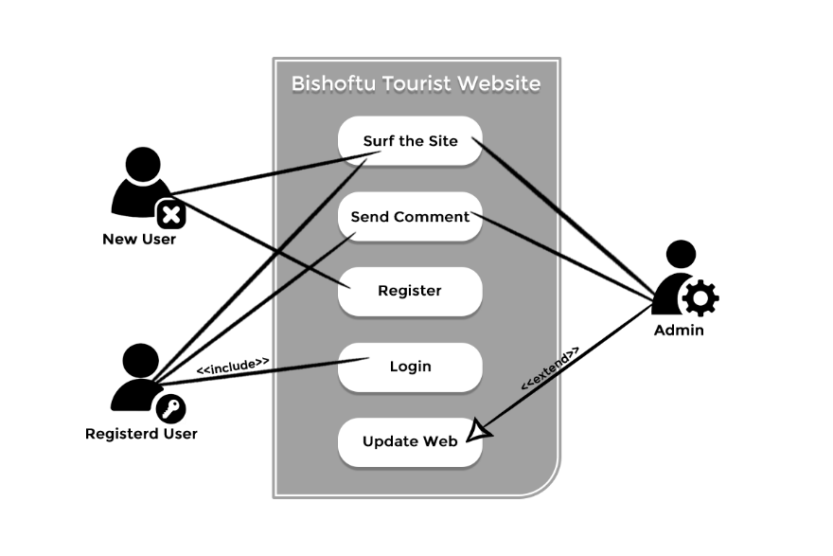

Picture 4.1 Case Diagram

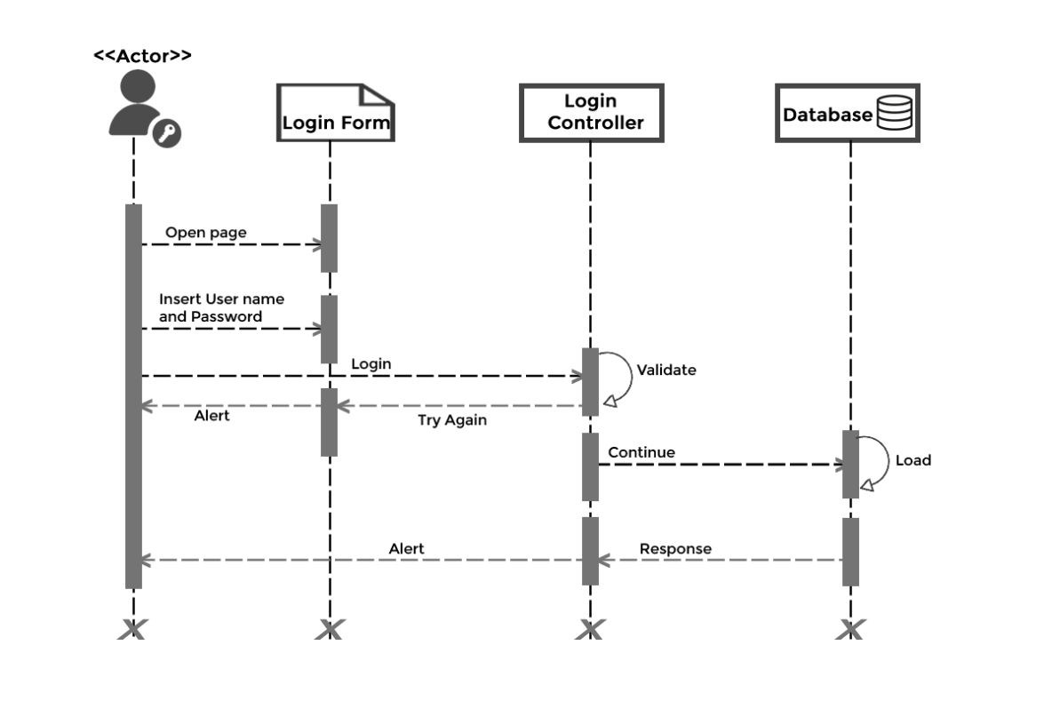

Picture 4.2 Login Sequence Diagram

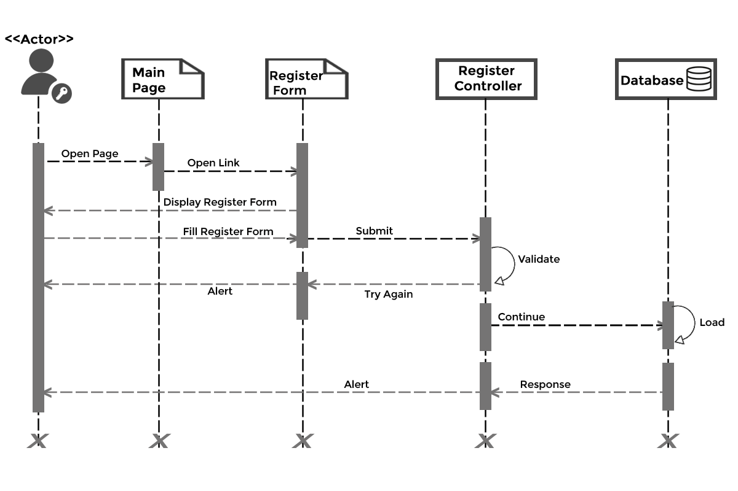

Picture 4.3 Registration Sequence Diagram